Gregory Bateson called it a *metalogue*: a conversation in which not only the topic is discussed, but the very form of the conversation reflects something of the topic itself. In a metalogue, questions and answers, feelings and ideas move in circles around each other — without rushing to solutions, but with attention to the patterns that give meaning to what we say, feel, and do.

The metalogue you’re about to read is an attempt to apply that way of thinking and speaking to a painful, current reality: the violence and what it does to us — as witnesses, as parents, as children, as human beings. We will never know whether Bateson would have written it this way. But we find it meaningful to link his approach to complexity, relationship, and ethics to this moment in time.

Perhaps this conversation between parent and child can help us not only *think* about war, powerlessness, and connection — but also *feel* what it means to still matter, even when we feel small.

**Metalogue: Dad, why is there a war?**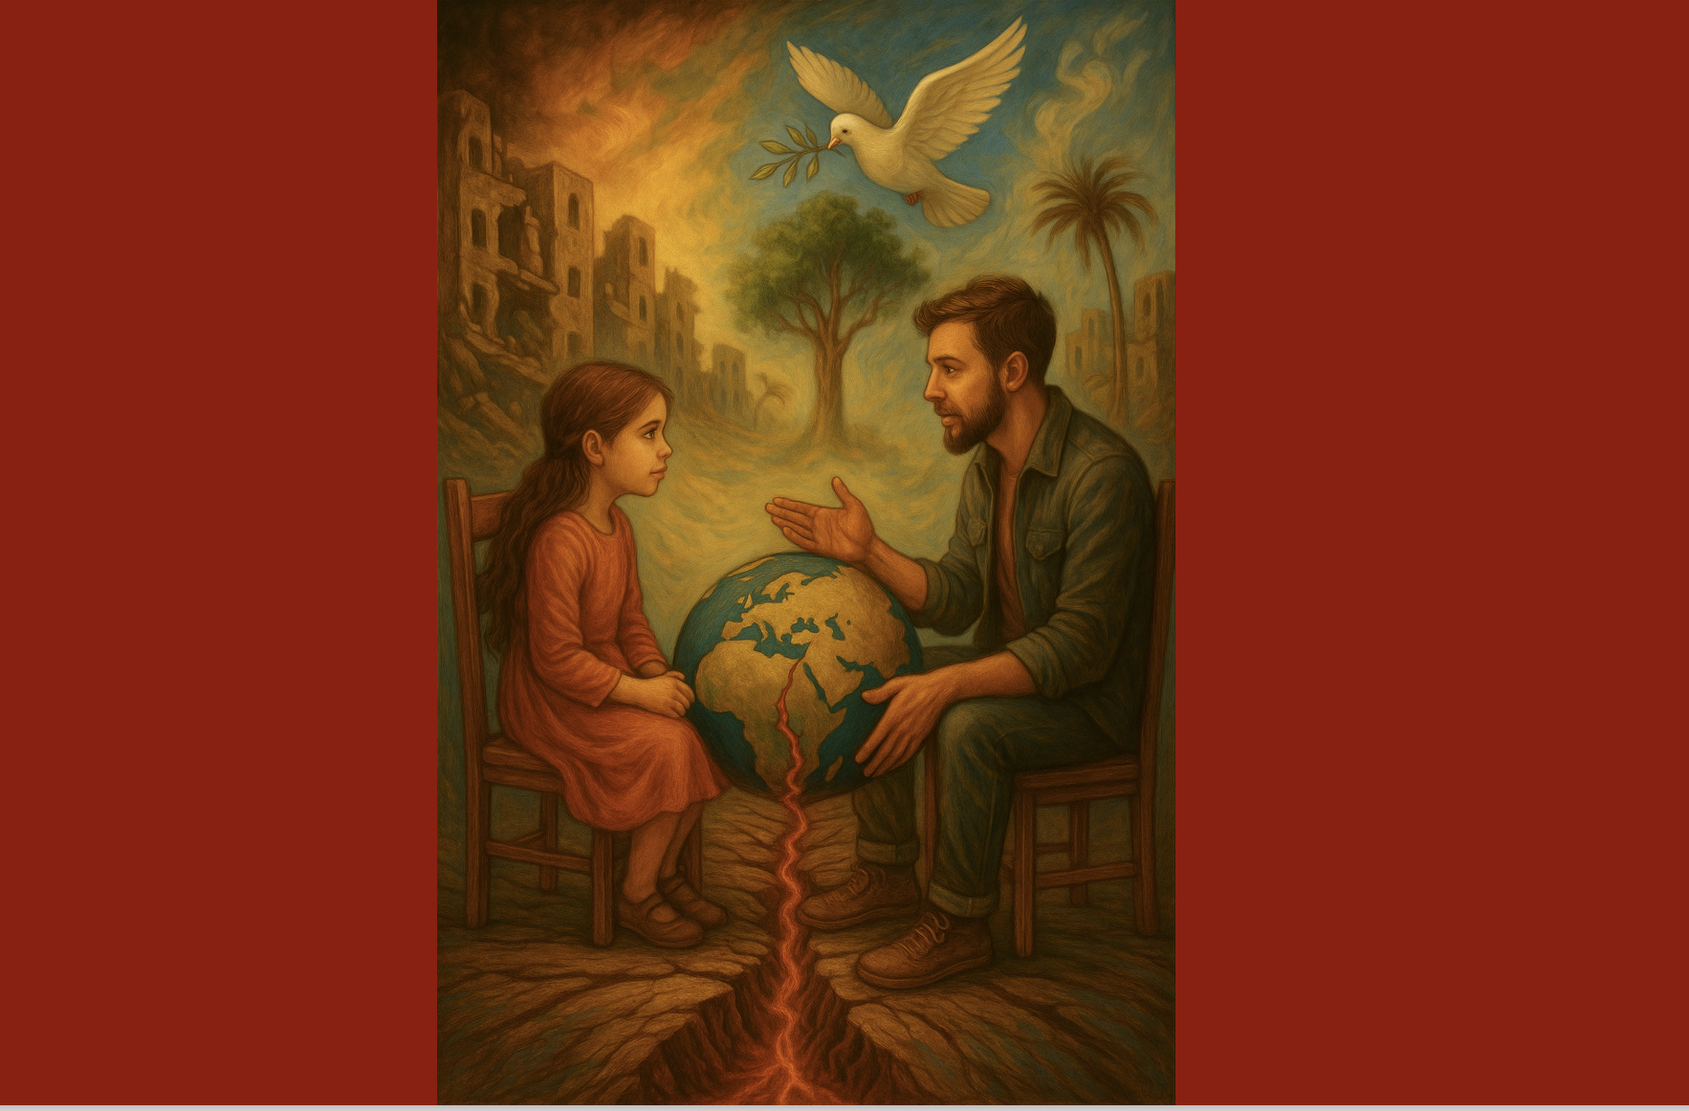

**Daughter:**  
Dad, why is there a war?

**Father:**  
Can I ask you something first?

**Daughter:**  
Yes?

**Father:**  
What do you feel when you see something terrible happening, and you don’t know what you can do about it?

**Daughter:**  
I feel angry. I want it to stop. And I feel pain... here. *(points to her chest)* And then suddenly I feel very small.

**Father:**  
Those feelings are exactly what this is about. They show that you are connected. That you see how someone else’s suffering also matters to you.

**Daughter:**  
But what good does it do? I can’t do anything, can I?

**Father:**  
That feeling of powerlessness is real. And dangerous — not because it’s wrong, but because it can make you believe that you don’t matter. When in fact, what you’re feeling is something many have forgotten: humanity.

**Daughter:**  
But I also feel angry. At the people who are doing this. And at the people who stay silent. Sometimes I just want to scream.

**Father:**  
Yes. And that’s understandable. Anger can be honest. It says: “This is not okay. This must stop.” But anger without grounding can harden. It’s a flame — and we have to learn how to carry that flame without letting it burn everything down.

**Daughter:**  
But it *is* terrible, isn’t it?

**Father:**  
It’s horrific. What’s happening there — children dying, people without water, hospitals being bombed — that’s not just war. That’s a violation of what it means to be human.

**Daughter:**  
And no one stops it?

**Father:**  
Some people try. Some protest, write, speak out. Others feel, like you, powerless. Not because they don’t care, but because they no longer know *how* to make a difference.

**Daughter:**  
It feels like everyone is lost.

**Father:**  
Yes. In a world that revolves around power, possession, and fear of losing something — people lose their ability to feel that we all belong to each other.

**Daughter:**  
Like with the Earth?

**Father:**  
Exactly. War isn’t just violence between people. It’s a way of thinking that says: “I am separate from you.” Or: “I have the right to take what I want.” We speak that way about nature too, sometimes.

**Daughter:**  
But we’re not separate, right?

**Father:**  
No, we’re not. But it takes practice to keep feeling that, especially when the world shouts that power is more important than care. Or that you shouldn’t doubt, or be sad.

**Daughter:**  
Am I allowed to be sad?

**Father:**  
Yes. Sadness is a form of love. It means you care about something — even if it’s far away.

**Daughter:**  
But what are we supposed to do with all these feelings?

**Father:**  
We carry them. Together. And we *do* something with them. Speak. Write. Learn. Listen. Go out into the street and protest. Not because you alone can stop the war, but because it means you don’t walk away from what it means to be human.

**Daughter:**  
Like we’re doing now?

**Father:**  
Like you’re doing now. Your anger, your sadness, your questions — they’re not weaknesses. They are threads of connection. And maybe peace begins there.

Auteur: Cinthe Lemmens